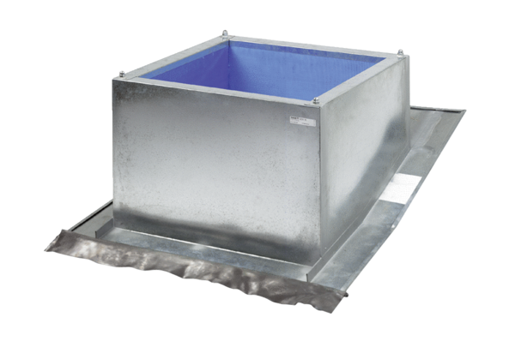Roof socket for pitched roofs SDS 22Packing unit: 1 pieceRange: C
Article number: 0093.0952Manufacturer: MAICO

