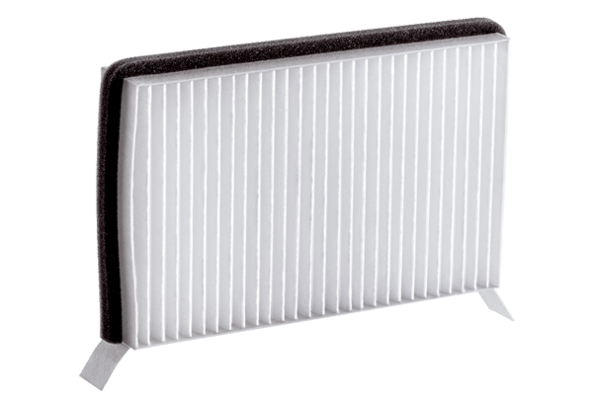Air filter, replacement Duo M6Packing unit: 1 pieceRange: K
Article number: 0093.1439Manufacturer: MAICO

