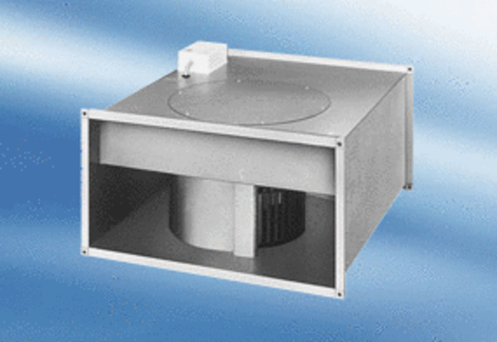Channel fan EPK 25/4 APacking unit: 1 pieceRange:
Article number: 0086.0613Manufacturer: MAICO

