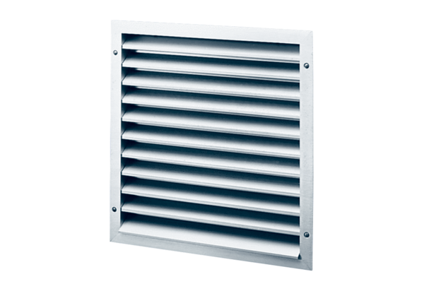External grille MLA 30Packing unit: 1 pieceRange: C
Article number: 0151.0113Manufacturer: MAICO

