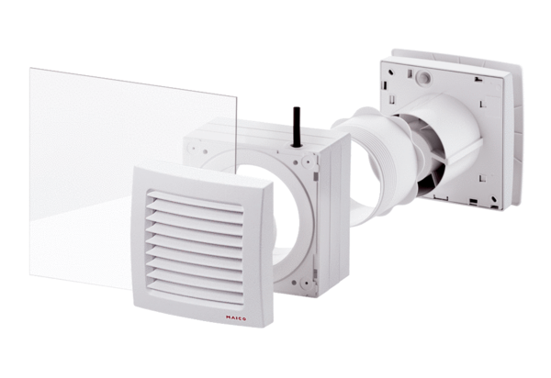Window installation kit FE 100/1 SGPacking unit: 1 pieceRange: A
Article number: 0093.0500Manufacturer: MAICO

