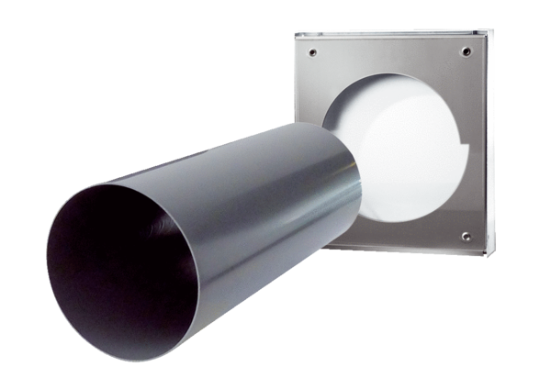Shell kit PP 60 KA-SRWPacking unit: 1 pieceRange: K
Article number: 0095.0215Manufacturer: MAICO

