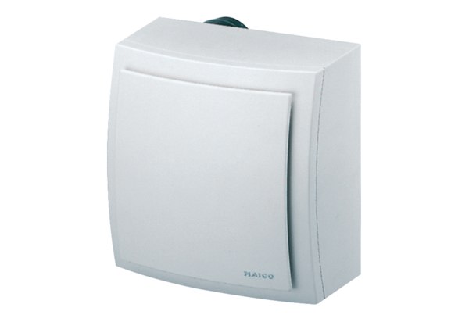Surface-mounted fan ER-AP 60 FPacking unit: 1 pieceRange: B
Article number: 0084.0152Manufacturer: MAICO

