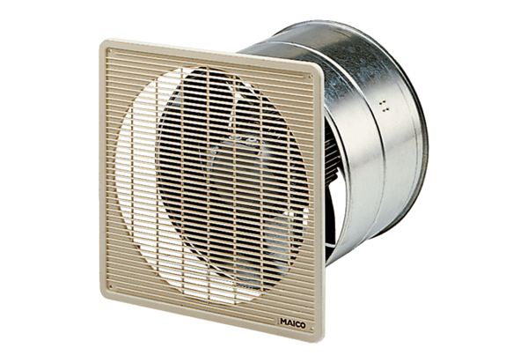EZF 20/4 EPacking unit: 1 pieceRange: C
Article number: 0085.0484Manufacturer: MAICO

