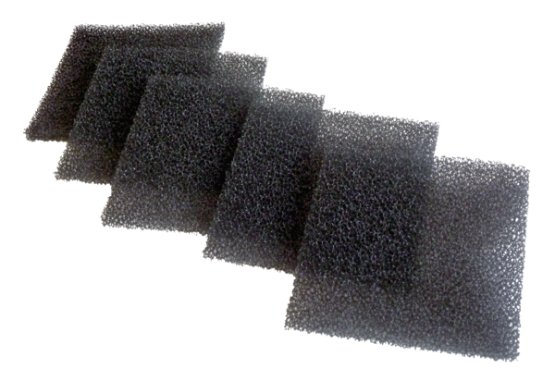Air filter, replacement AZPPacking unit: 5 piecesRange: K
Article number: 0093.0929Manufacturer: MAICO

