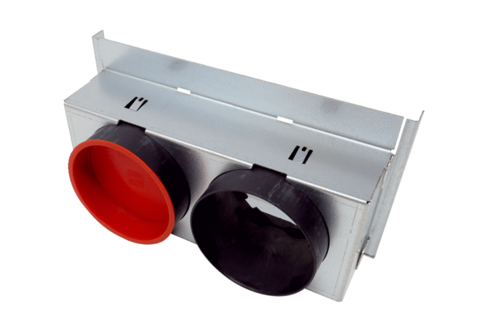Sheet metal adapters WS 75 APacking unit: 1 pieceRange: K
Article number: 0093.1585Manufacturer: MAICO

