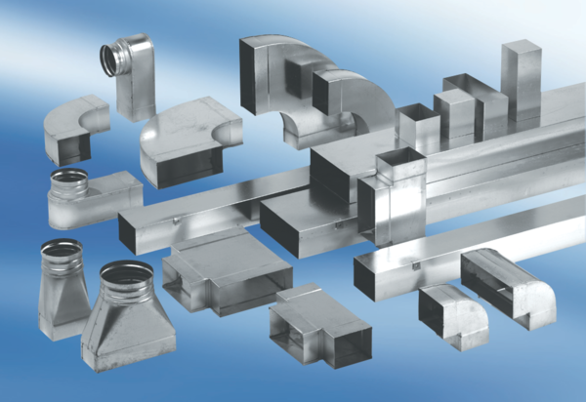45° channel elbows, vertical KB45V/55/110Packing unit: 1 pieceRange: K
Article number: 0055.0600Manufacturer: MAICO

