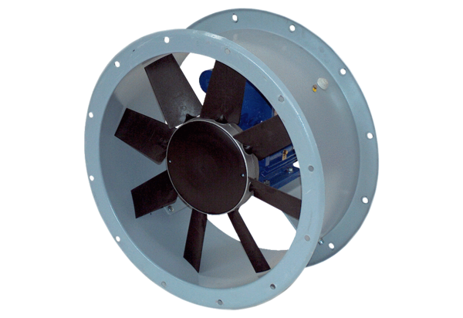Axial duct fan DAR 100/8-3 ExPacking unit: 1 pieceRange: C
Article number: 0073.0380Manufacturer: MAICO

