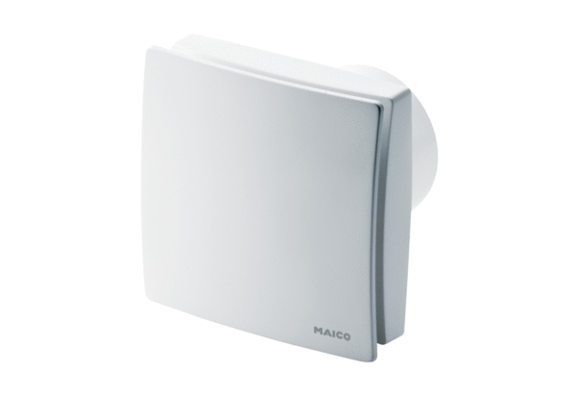Small room fan ECA 150 ipro KRCHPacking unit: 1 pieceRange: A
Article number: 0084.0094Manufacturer: MAICO

