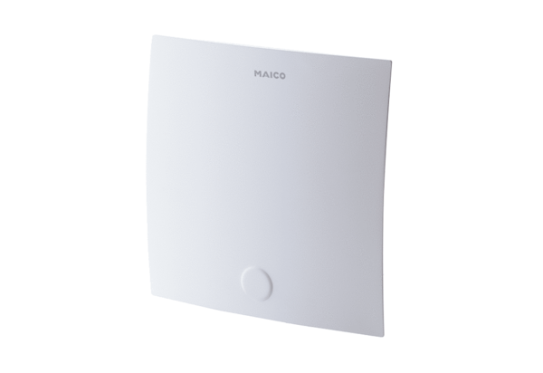Cover – upper part ABDO ER-ABRange: B
Article number: E059.2047.9000Manufacturer: MAICO

