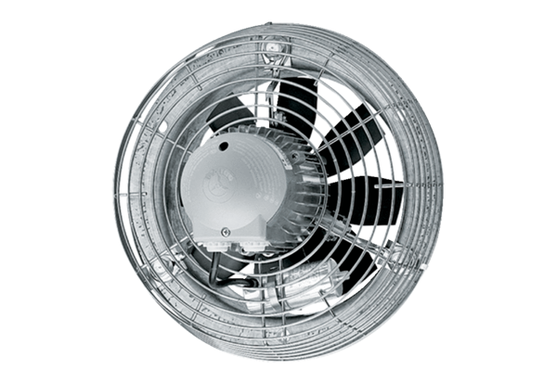Axial wall fan DZS 30/64 BPacking unit: 1 pieceRange: C
Article number: 0094.0043Manufacturer: MAICO

