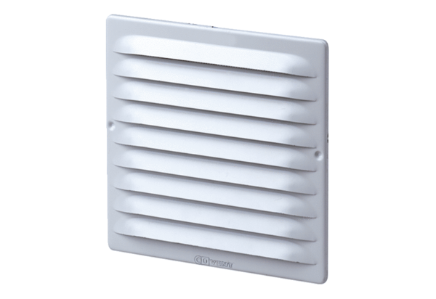External grille MGE 80/125 V2APacking unit: 1 pieceRange: K
Article number: 0078.0031Manufacturer: MAICO

