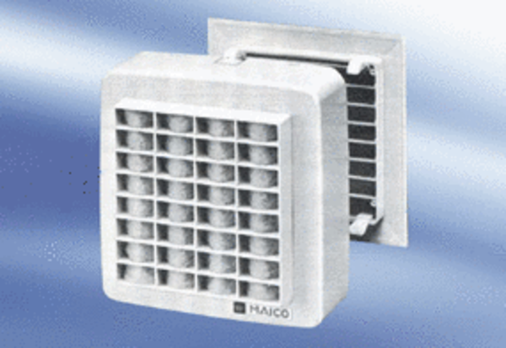Wall-mounted fan EMA 17Packing unit: 1 pieceRange:
Article number: 080279Manufacturer: MAICO

