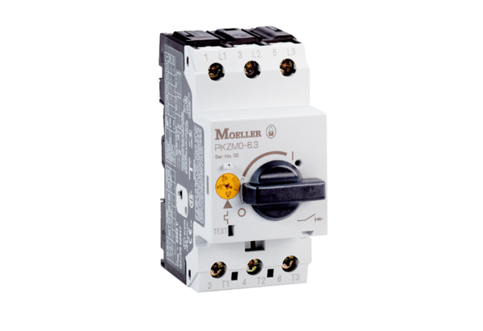Motor protection switch MVEx 1,0Packing unit: 1 pieceRange: D
Article number: 0157.0548Manufacturer: MAICO

