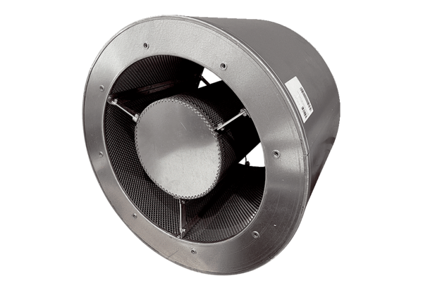Tubular sound absorber RSKI 112/1000Packing unit: 1 pieceRange: C
Article number: 0073.0253Manufacturer: MAICO

