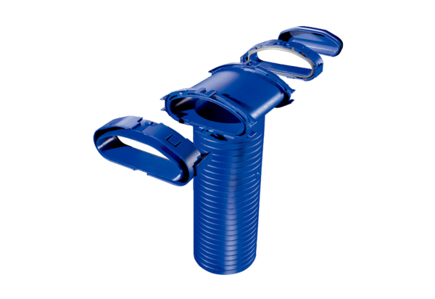Wall/Ceiling outlet FFS-WAPacking unit: 1 pieceRange: K
Article number: 0055.0875Manufacturer: MAICO

