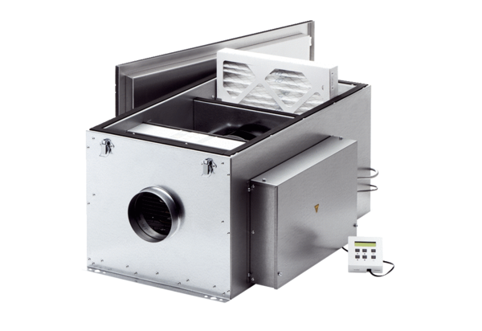Compact box ECR 12 ECPacking unit: 1 pieceRange: E
Article number: 0080.0574Manufacturer: MAICO

