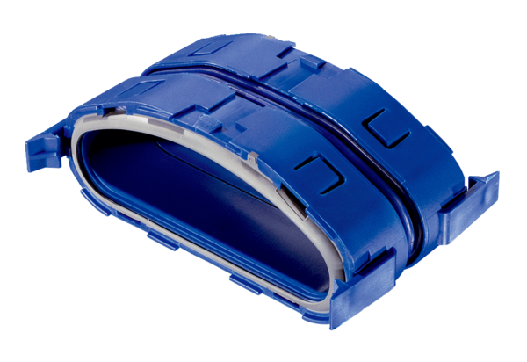Connection pieces FFS-VSPacking unit: 5 piecesRange: K
Article number: 0055.0882Manufacturer: MAICO

