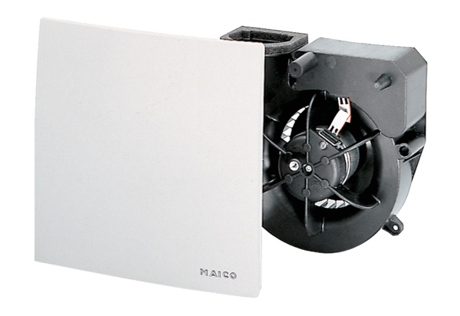Fan insert ER 100 RCPacking unit: 1 pieceRange: B
Article number: 0084.0129Manufacturer: MAICO

