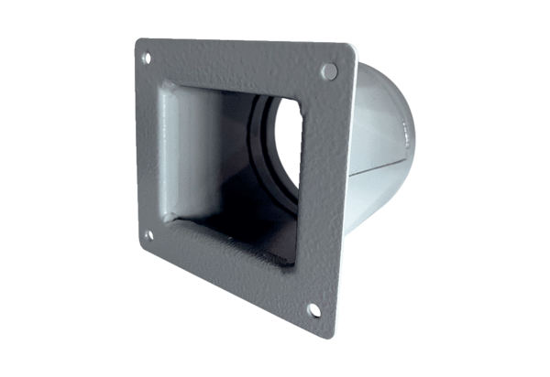Transition adapter URRI 16Packing unit: 1 pieceRange: C
Article number: 0073.0300Manufacturer: MAICO

