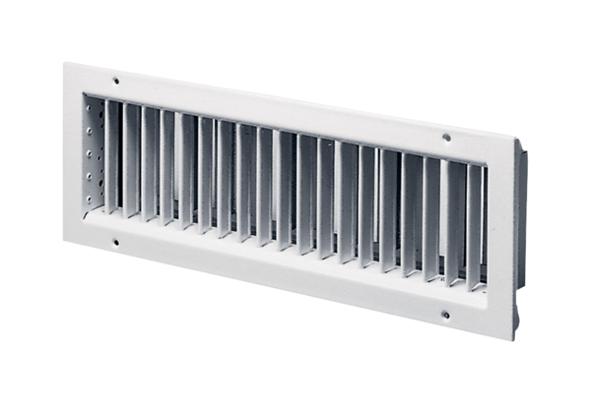Internal grille LGA 42/12Packing unit: 1 pieceRange: D
Article number: 0151.0260Manufacturer: MAICO

