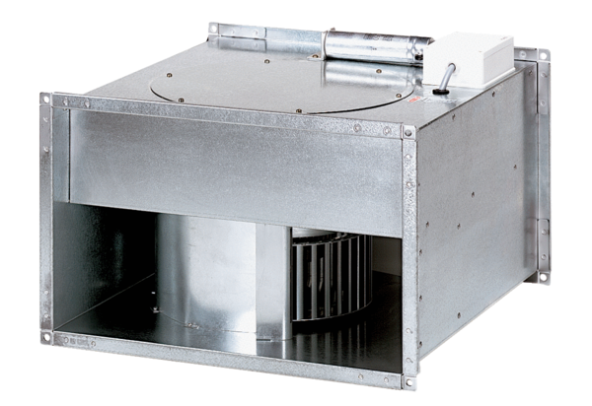Channel fan DPK 22/6 BPacking unit: 1 pieceRange: D
Article number: 0086.0660Manufacturer: MAICO

