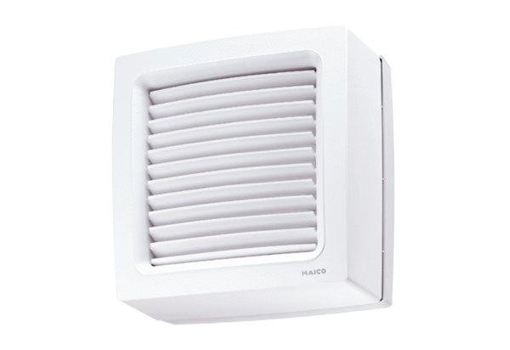Axial window fan EVN 15 PPacking unit: 1 pieceRange: C
Article number: 0080.0854Manufacturer: MAICO

