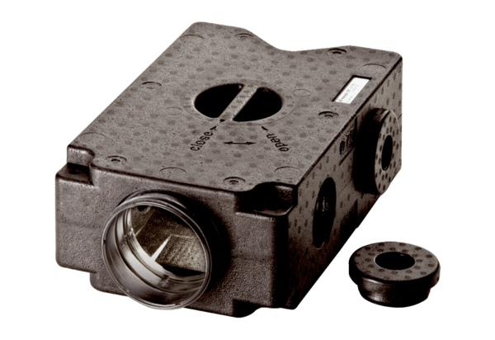Air distributor made of plastic, 4-way MF-V90Packing unit: 1 pieceRange: K
Article number: 0059.0968Manufacturer: MAICO

