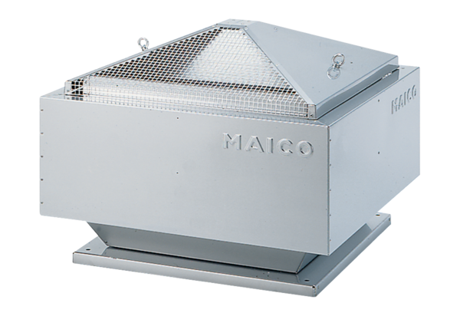Centrifugal roof fan DRD 45/4 BPacking unit: 1 pieceRange: C
Article number: 0087.0110Manufacturer: MAICO

