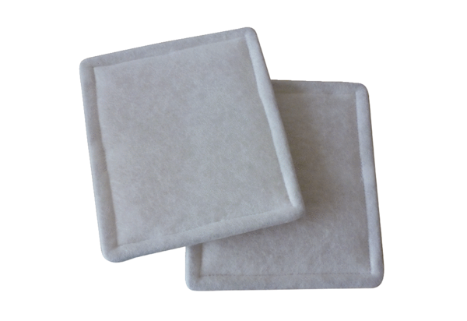Air filter, replacement RF 20Packing unit: 2 piecesRange: C
Article number: 0093.0693Manufacturer: MAICO

