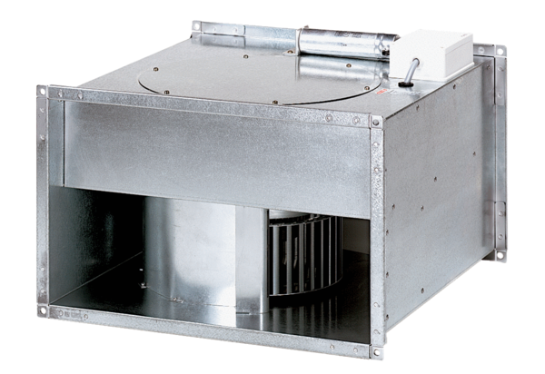Channel fan DPK 25/4 BPacking unit: 1 pieceRange: D
Article number: 0086.0663Manufacturer: MAICO

