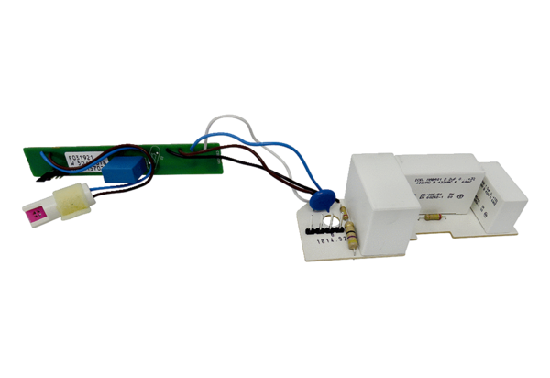Circuit board PL ER 60 HRange: B
Article number: E101.1014.9207Manufacturer: MAICO

