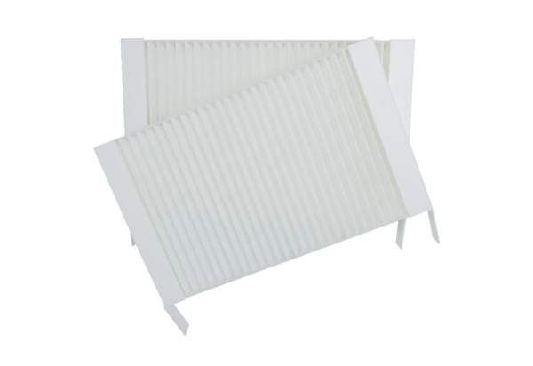Air filter, replacement WS 75 G4Packing unit: 2 piecesRange: K
Article number: 0093.1589Manufacturer: MAICO

