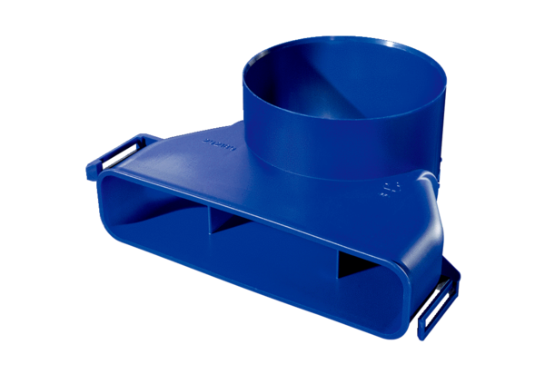Vertical air distributor transition piece FFS-VTVÜPacking unit: 1 pieceRange: K
Article number: 0055.0900Manufacturer: MAICO

