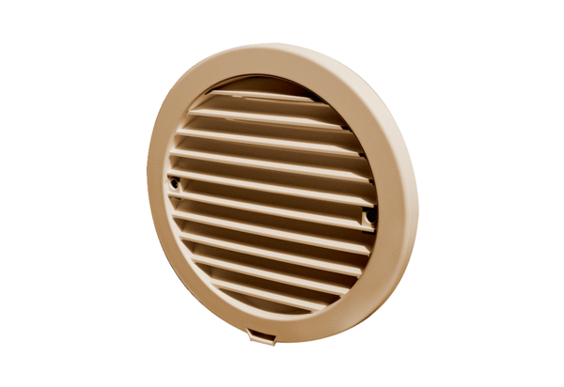External cover PP 45 AKBPacking unit: 1 pieceRange: K
Article number: 0093.1636Manufacturer: MAICO

