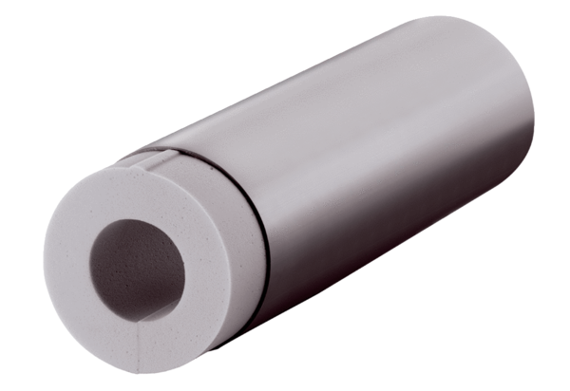Extension kit ALDVS 160Packing unit: 1 pieceRange: B
Article number: 0152.0086Manufacturer: MAICO

