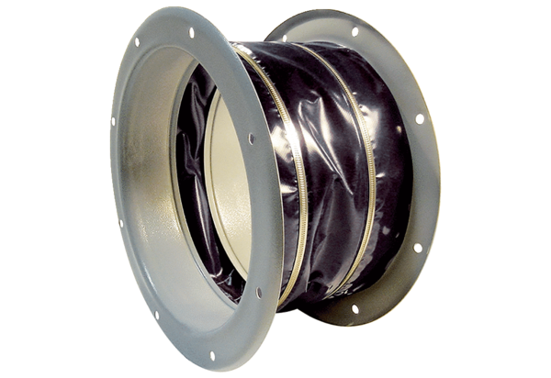Flexible coupling ELI 71 ExPacking unit: 1 pieceRange: C
Article number: 0073.0579Manufacturer: MAICO

