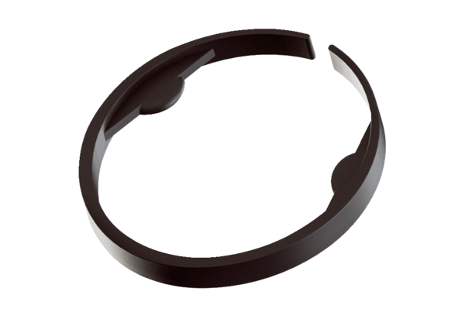Clamp MA-KL90Packing unit: 10 piecesRange: K
Article number: 0059.2136Manufacturer: MAICO

