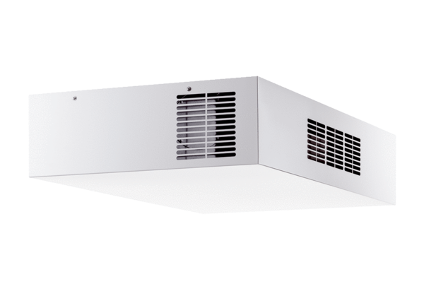Decentralised ventilation unit with heat recovery Trio QD-ALVPacking unit: 1 pieceRange: K
Article number: 0095.0121Manufacturer: MAICO

