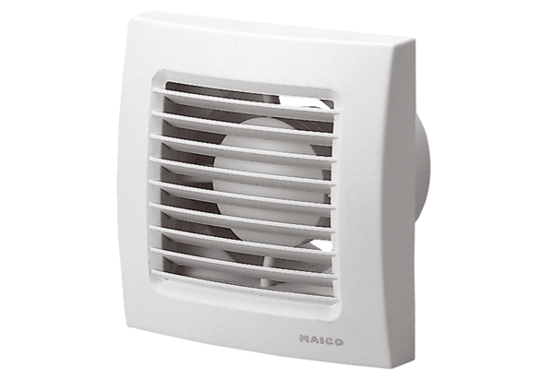Small room fan ECA 100 PPacking unit: 1 pieceRange: A
Article number: 0084.0032Manufacturer: MAICO

