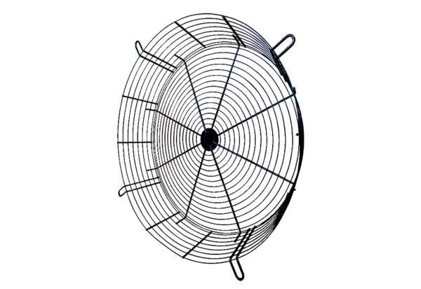Protection against accidental contact SGCI 112Packing unit: 1 pieceRange: C
Article number: 0073.0214Manufacturer: MAICO

