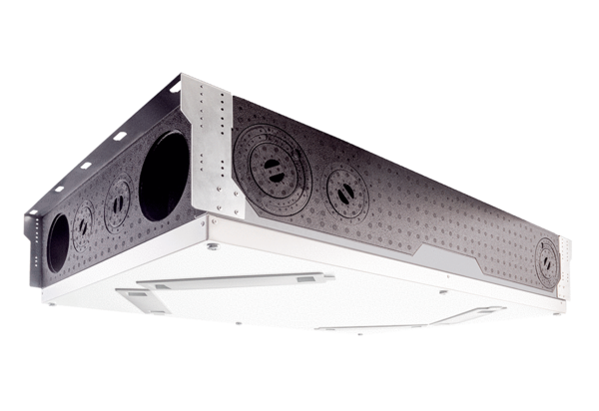Centralised ventilation unit WS 120 Trio QRVPacking unit: 1 pieceRange: K
Article number: 0095.0662Manufacturer: MAICO

