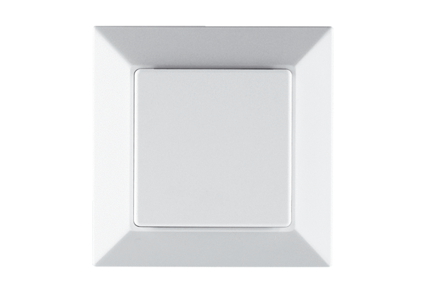VOC sensor PP 45 VOCPacking unit: 1 pieceRange: K
Article number: 0157.0367Manufacturer: MAICO

