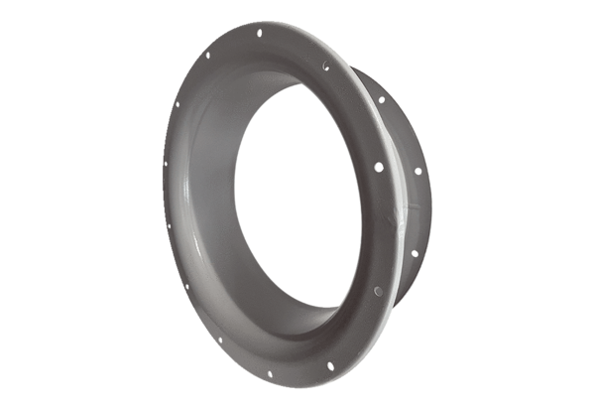Suction nozzle ADI 90Packing unit: 1 pieceRange: C
Article number: 0073.0237Manufacturer: MAICO

