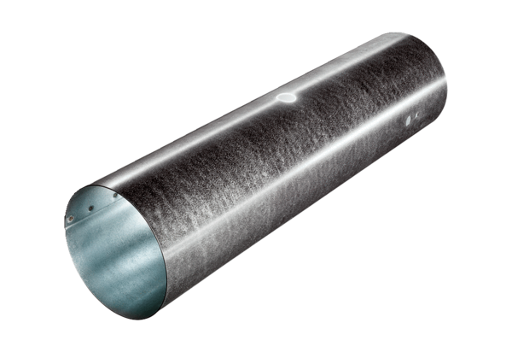Duct piece for servomotor MSR 160Packing unit: 1 pieceRange: C
Article number: 0092.0513Manufacturer: MAICO

