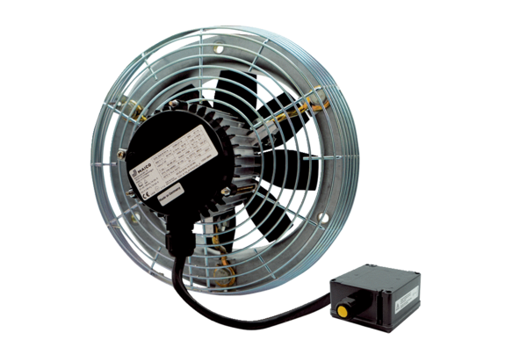Axial wall fan DZS 25/4 B Ex ePacking unit: 1 pieceRange: C
Article number: 0094.0118Manufacturer: MAICO

