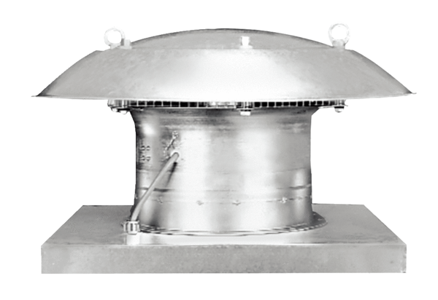Axial roof fan DZD 60/6 BPacking unit: 1 pieceRange: C
Article number: 0087.0228Manufacturer: MAICO

