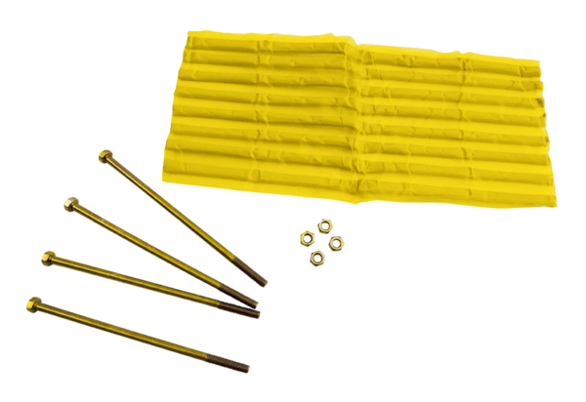Accessories for glass brick walls ZG 26Packing unit: 1 pieceRange: C
Article number: 0093.0157Manufacturer: MAICO

