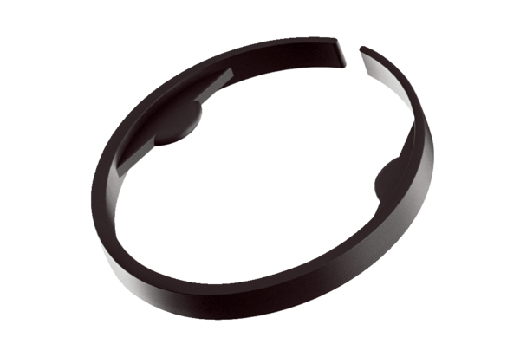Clamp MA-KL75Packing unit: 10 piecesRange: K
Article number: 0059.2135Manufacturer: MAICO

