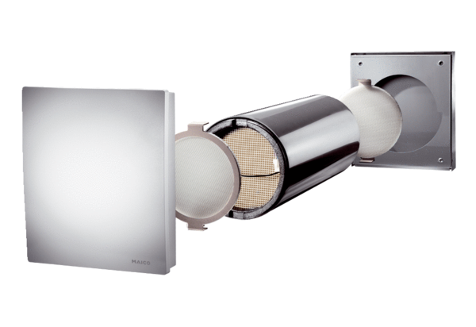Complete set PP 60 KAPacking unit: 1 pieceRange: K
Article number: 0095.0202Manufacturer: MAICO

